미국 부동산 중개 플랫폼

[https://www.zillow.com](https://www.zillow.com/ca/rentals/?searchQueryState=%7B%22mapBounds%22%3A%7B%22west%22%3A-121.58924078191164%2C%22east%22%3A-121.55709718907717%2C%22south%22%3A36.96267670038273%2C%22north%22%3A36.990926857532%7D%2C%22isMapVisible%22%3Atrue%2C%22filterState%22%3A%7B%22fsba%22%3A%7B%22value%22%3Afalse%7D%2C%22fsbo%22%3A%7B%22value%22%3Afalse%7D%2C%22nc%22%3A%7B%22value%22%3Afalse%7D%2C%22fore%22%3A%7B%22value%22%3Afalse%7D%2C%22cmsn%22%3A%7B%22value%22%3Afalse%7D%2C%22auc%22%3A%7B%22value%22%3Afalse%7D%2C%22pmf%22%3A%7B%22value%22%3Afalse%7D%2C%22pf%22%3A%7B%22value%22%3Afalse%7D%2C%22fr%22%3A%7B%22value%22%3Atrue%7D%2C%22ah%22%3A%7B%22value%22%3Atrue%7D%7D%2C%22isListVisible%22%3Atrue%2C%22regionSelection%22%3A%5B%7B%22regionId%22%3A9%2C%22regionType%22%3A2%7D%5D%2C%22usersSearchTerm%22%3A%22California%22%2C%22schoolId%22%3Anull%2C%22mapZoom%22%3A15%7D)

<https://www.trulia.com/>

<https://www.realtor.com/>

<https://www.redfin.com/>

<https://www.forsalebyowner.com/>

한국 중개 플랫폼과의 차이점

* 단촐한 디자인
* 최소 사진갯수 40개 이상(한국의경우 30개 이상인 매물이 적음)
* 외관, 주위환경, 등 많은사진을 첨부함

일본 부동산 중개 플랫폼

<https://suumo.jp/>

<https://www.athome.co.jp/>

<https://www.homes.co.jp/>

한국 중개 플랫폼과의 차이점

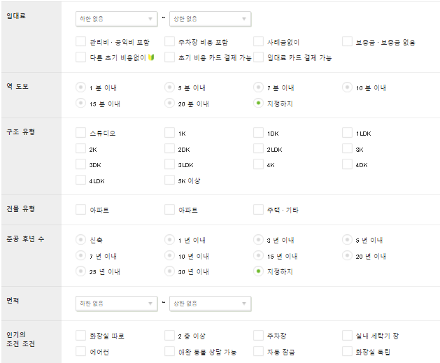

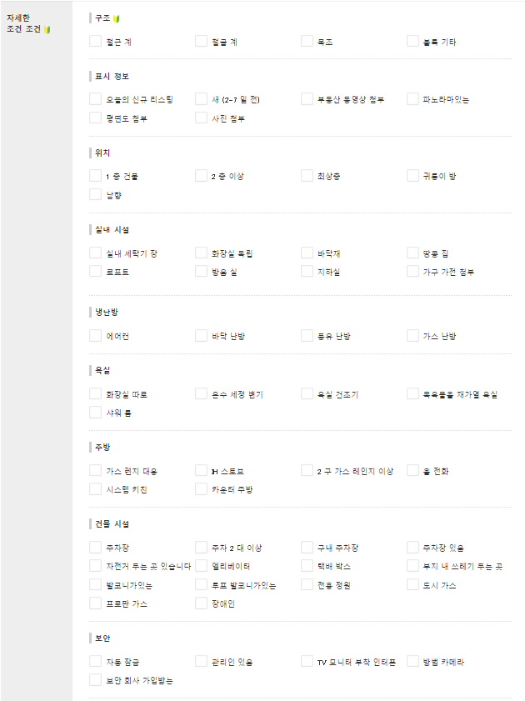

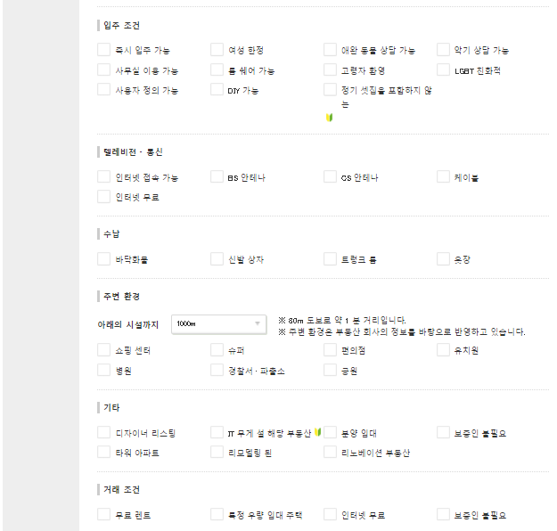

중국 부동산 중개 플랫폼

**贝壳找房 베이커 쟈오팡**

**安居客 안쥐커**

**​**

**58同城租房 58통청쥬팡**

**租房 쥬팡 (방동직매물)**

**自如** 쯔루

현재 그집에 사는사람의 성별 직군 별자리 등이나온다.

한국과 가장 비슷함

허위매물